NAMA KELOMPOK

Nama : Dani Fahdlu Rohman Silaen

NPM : 232310027

Nama : Hery Tua Sigalingging

NPM :232310030

Jurusan : Teknologi Informasi

Kelas : TI-23-PA

PRAKTIKUM : PERTEMUAN 13

Mata Kuliah : **[Lab. Algoritma Pemrograman & Struktur Data Shania Oktaviani G, MTCNA TI-23-PA1](https://elearning.ibik.ac.id/course/view.php?id=2373)**

TUGAS PERTEMUAN 13

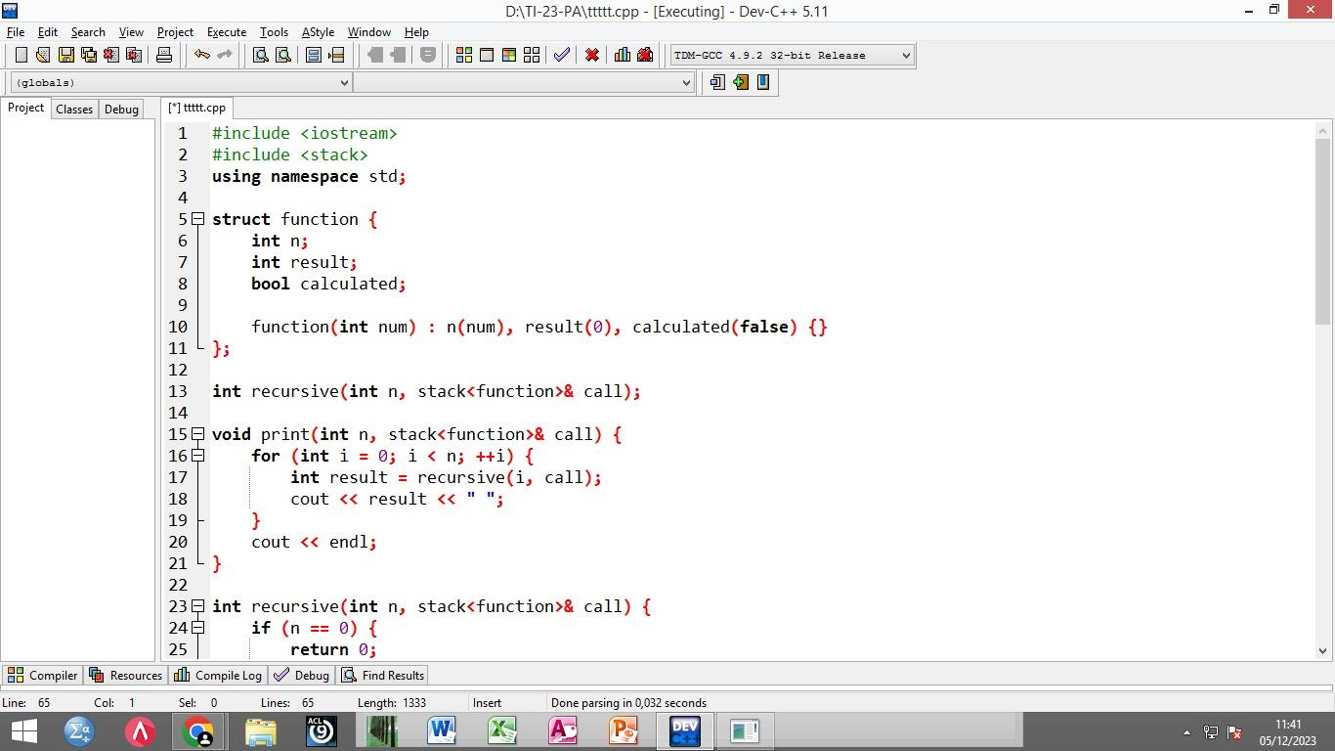

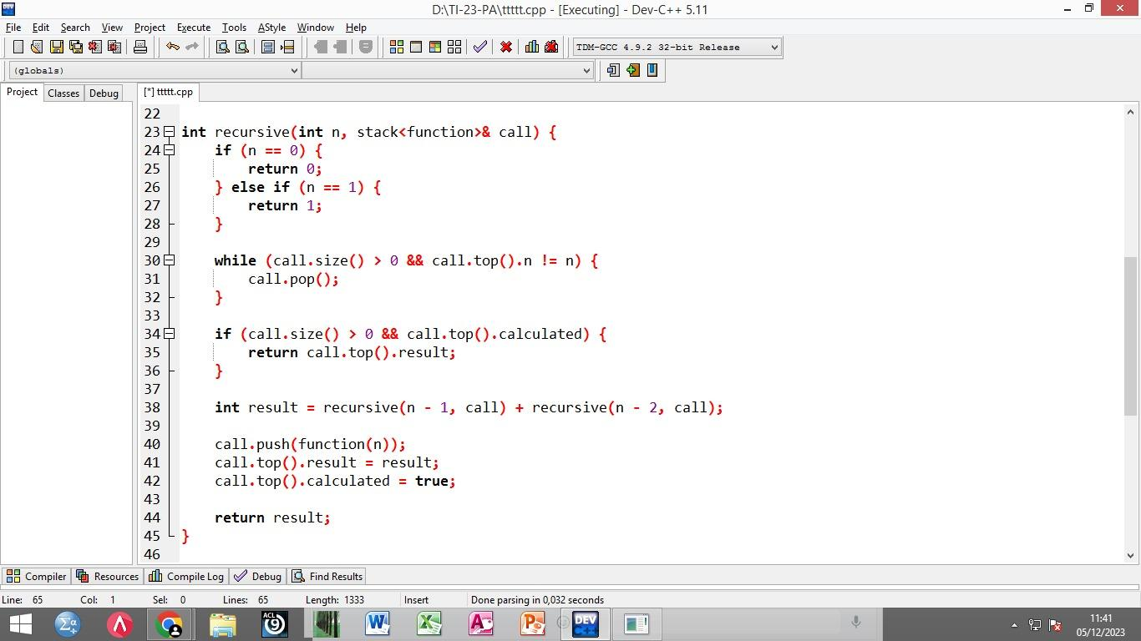

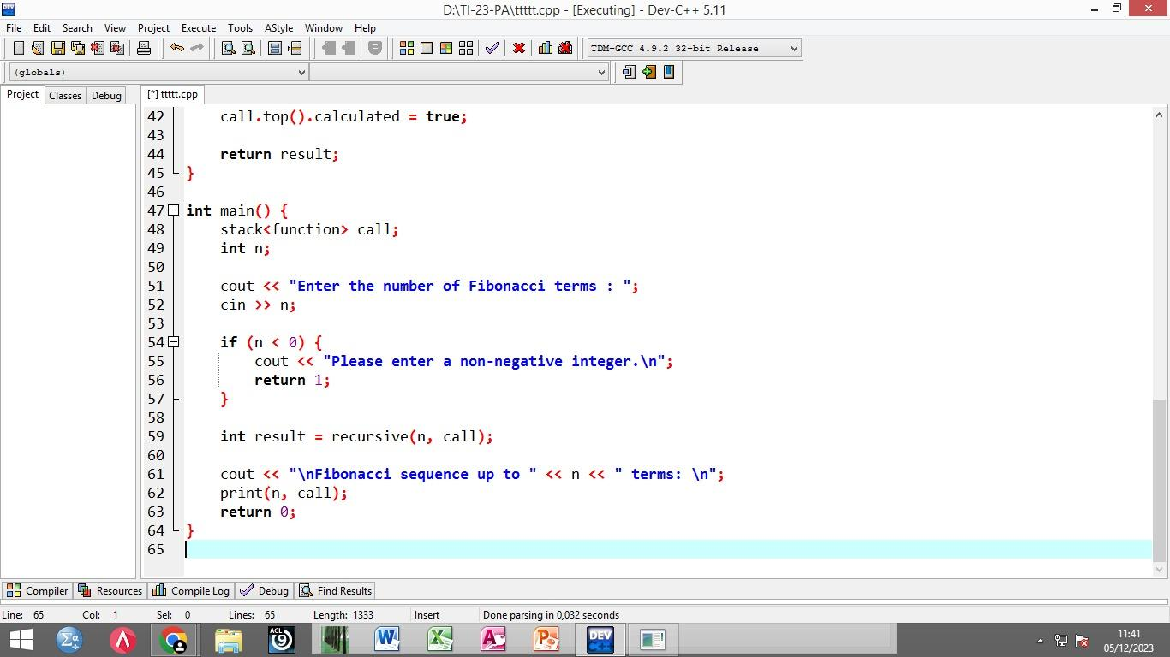

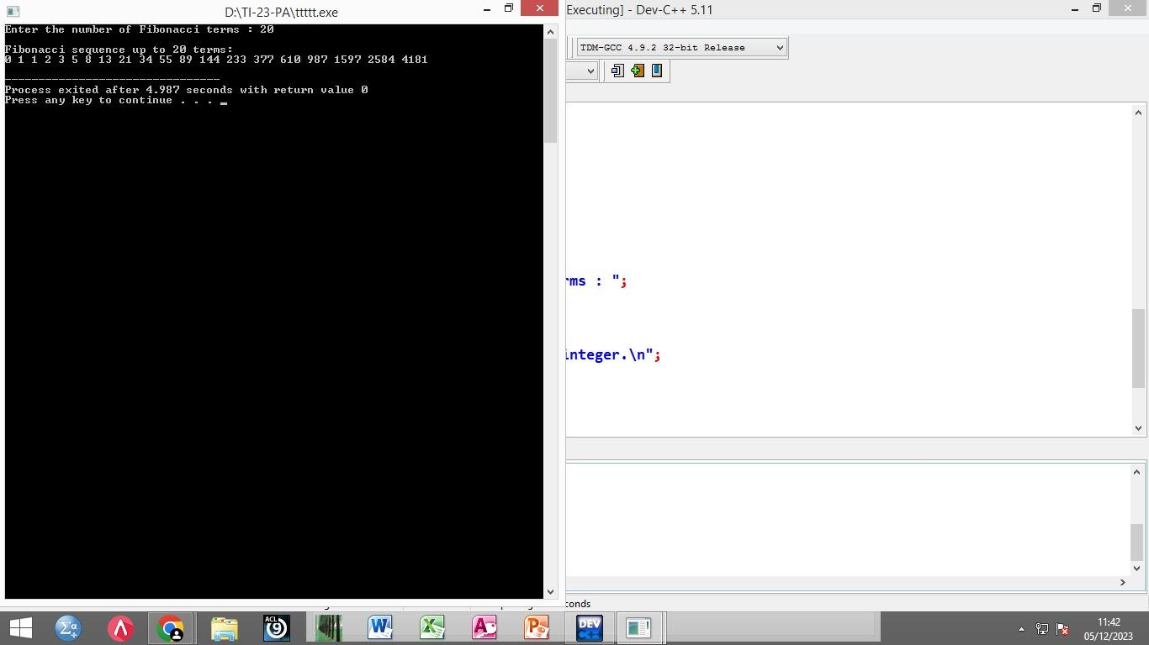

RESOURCE CODE :

#include <iostream>

#include <stack>

using namespace std;

struct function {

int n;

int result;

bool calculated;

function(int num) : n(num), result(0), calculated(false) {}

};

int recursive(int n, stack<function>& call);

void print(int n, stack<function>& call) {

for (int i = 0; i < n; ++i) {

int result = recursive(i, call);

cout << result << " ";

}

cout << endl;

}

int recursive(int n, stack<function>& call) {

if (n == 0) {

return 0;

} else if (n == 1) {

return 1;

}

while (call.size() > 0 && call.top().n != n) {

call.pop();

}

if (call.size() > 0 && call.top().calculated) {

return call.top().result;

}

int result = recursive(n - 1, call) + recursive(n - 2, call);

call.push(function(n));

call.top().result = result;

call.top().calculated = true;

return result;

}

int main() {

stack<function> call;

int n;

cout << "Enter the number of Fibonacci terms : ";

cin >> n;

if (n < 0) {

cout << "Please enter a non-negative integer.\n";

return 1;

}

int result = recursive(n, call);

cout << "\nFibonacci sequence up to " << n << " terms: \n";

print(n, call);

return 0;

}